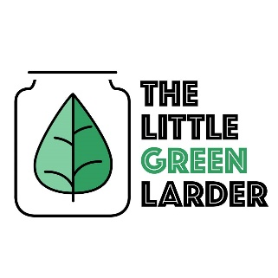

The Little Green Larder The Little Green Larder

Falafel burgers, guac and salad Falafel burgers, guac and salad

Falafel mix  
2 rolls  
Avocado  
Garlic  
Lime  
Chilli  
Courgette  
Red onion  
Cherry tomatoes  
Carrot

- add water 1tbsp at a time to falafel mix until it holds together, set aside for 10 mins then shape into 2 patties

- Use a veg peeler to ribbon the carrot and courgette, chop onion and half of the cherry tomatoes. Mix in bowl, add ½ chillie if you want a bit of spice and squeeze ½ a lime over, salt and pepper to taste

- for guacamole mash avocado, mix with 1 – 2 garlic cloves, ¼ of the onion, chopped fresh tomatoes, ½ of the chilli and squeeze ½ of the lime juice in. Salt and pepper to taste.

- Fry the falafel burgers in oil for a few mins each side and serve on roll

Serves 2 Serves 2

Falafel mix  
2 rolls  
Avocado  
Garlic  
Lime  
Chilli  
Courgette  
Red onion  
Cherry tomatoes  
Carrot

- add water 1tbsp at a time to falafel mix until it holds together, set aside for 10 mins then shape into 2 patties

- Use a veg peeler to ribbon the carrot and courgette, chop onion and half of the cherry tomatoes. Mix in bowl, add ½ chillie if you want a bit of spice and squeeze ½ a lime over, salt and pepper to taste

- for guacamole mash avocado, mix with 1 – 2 garlic cloves, ¼ of the onion, chopped fresh tomatoes, ½ of the chilli and squeeze ½ of the lime juice in. Salt and pepper to taste.

- Fry the falafel burgers in oil for a few mins each side and serve on roll